Commonwealth of Virginia
Thomas A. Lisk, Chair  Andrew Kubincanek, Program Coordinator | 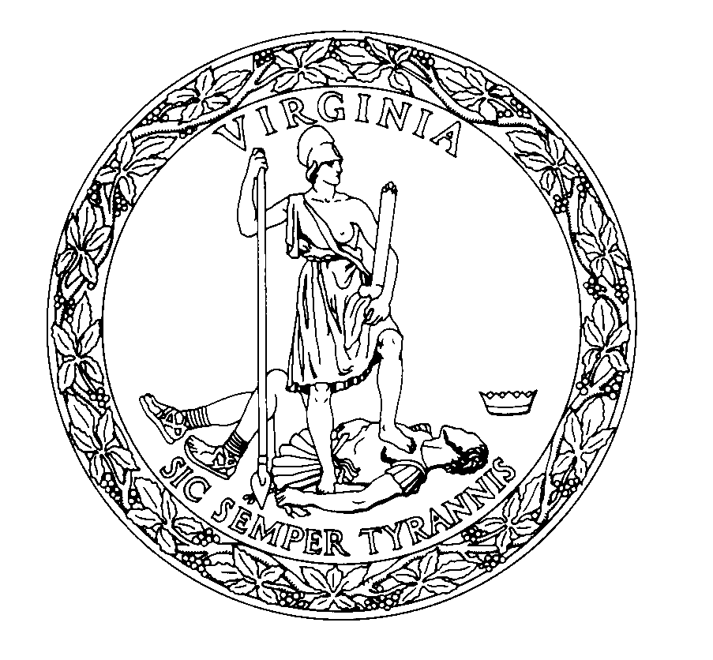 | General Assembly Building  201 North 9th Street, Fourth Floor  Richmond, Virginia 23219  (Phone) 804-698-1827  akubincanek@dls.virginia.gov  http://codecommission.dls.virginia.gov/alac/alac.shtml
Administrative Law Advisory Committee

Agenda
Administrative Law Advisory Committee
December 8, 2023 – 10:30 AM
Subcommittee Room 300 – General Assembly Building

I. Welcome and call to order

Tom Lisk, Chair

II. Hearing Officer Desk Book Updates

III. Public Comment/Adjourn

